Technical Report
Richard, Krishna, and Kasten

Technical Report 1
Product Development 1
Frontend 1
Backend 2
Model 0 (The Prototype) 2
Model 1 (TimescaleDB, SelfQuery) 4
Model 2 (Semantic Chunking) 5
Product Evaluation 8
Engineering the Evaluation Metrics 8
Evaluation Results 12
Bibliography 14
Contributions 15

Product Development

Frontend
After weighing our options, we decided to settle with using the Flutter framework to create a mobile app which could support our application. Having never worked with Flutter before, the first step we took was to research the Flutter documentation, which also required us to research the Dart language which forms the foundation for Flutter. Of course, there were many other aspects of Flutter which required further reading, but these tools (or more specifically, “widgets”) were studied when they became needed in our project. In addition to the base Flutter documentation, a fair amount of time was also spent reading the APIs for the custom libraries that we imported for implementing certain pieces of app functionality; these include the popular Riverpod library for state management (more on that below) and flutter_markdown among many others.

To start, we developed a simple app which contained two pages: a home screen and a chat screen. The core message summarization aspect was to be contained on the chat screen, while the home screen would serve to elevate the user experience and allow for quick shortcuts, as one might expect of a traditional mobile app. To allow basic navigation, we implemented a bottom tab bar and simply updated the displayed page whenever a tab bar button was tapped. However, a problem quickly emerged: how do we cleanly handle state management, especially in a multi-page app? While the official Flutter tutorial that we consulted recommended using the Flutter Provider library for basic state management, our research on StackOverflow and elsewhere suggested that Provider was perhaps not the best suited for our needs. Rather, there were some issues with Provider, such as each provider object needing a unique return type, that seemed like a hassle to deal with from the get go, and so we quickly settled on using the Riverpod library for state management. Of course, Riverpod itself was a new tool that we had to research, and while the documentation was extensive, there were particular edge cases which required us to research on our own. However, once we finally figured out how to use Riverpod, the rest of the app development proceeded quite smoothly.

In the process of implementing simple network requests, we had to perform some asynchronous programming to allow sending requests, waiting for responses, and processing responses on completion. For simplicity, we assumed that requests would always succeed—that is, we didn’t handle network errors. However, we did implement message loading on the app side, which we accomplished by following a Flutter cookbook to create a typing indicator.

Once simple requests and search history were working, we worked on enhancing the user experience by implementing some basic interactions, including button highlighting (this refers to how buttons might change color when held for a long time), input disabling, and the aforementioned typing indicator. Once those were taken care of, we moved on to implementing some miscellaneous features, such as friend profiles and app settings. The most relevant of the app settings include the ability to edit one’s profile and manage one’s search and chat history, but we also included some appearance options for “completeness”. More interestingly, we updated our network requests to the backend server to include user and friend profile info in their request body for a given user search, allowing the backend server to take this info into consideration when considering possible aliases. With that, this concludes the bulk of the frontend development. As mentioned in Richard’s contribution statement, the “beauty” of the app perhaps speaks for itself and the time that went into developing a pleasant user experience.

Backend

Model 0 (The Prototype)
Model 0 used the following stack:


Preprocessing

vector
Parser
Pure Python
Operations Key

string, datetime
Vectorize Agent
LangChain (LLAMA 3B backend)

Retrieval
User Query
Retrieve top 10 messages
(cos-sim)
[Message + Metadata]
Query Vector
[Retrieved messages ± context]
Vectorize Agent

Summary

Summary Agent
Add context (±10 messages)

Model 0 was our first pipeline that could answer questions based on our messages (and the first successful app any of us had made with LLMs). We learned a lot from this process: how to parse messages from these apps, how to retrieve metadata such as datetime and message ID from a vector database, and how to integrate pure Python routines with LangChain (the key here was to prompt LLMs to return JSON-formatted outputs and then convert those JSON strings to Python objects).

While a great start, Model 0 had many drawbacks. The vectors stored in the database were based on single messages and lacked information about that message’s context. Because our use case is primarily context driven, i.e., users might ask “What was the last thing Kasten asked me to do?” we were concerned at the poor alignment between retrieved messages and the messages we expected as answers to our questions. Our idea of adding ±10 messages’ context did not solve this problem because the initial retrieved message was often low quality.

For Model 0.1, we tried to fix this issue by adding another context retrieval agent that added ±5 messages to each message before it was vectorized. This change to the preprocessing step made our model retrieve the correct document (in limited manual testing). However, there were some very apparent drawbacks: the Summary Agent would include information about retrieved conversation snippets that were unrelated to the question. To solve this issue, we proposed using LLM agents to assess whether context snippets were related to the question. Another issue we identified is that users will likely ask time-sensitive questions, e.g., “When is my next meeting with Kasten and Richard?” or “Which films did my friends watch in February?” Since ChromaDB only allows for querying by vector similarity, we needed to change our stack to make sure that time-sensitive constraints are applied at retrieval time.

(For your reference, we presented Model 0.1 in Presentation #2 on February 6th)

Model 1 (TimescaleDB, SelfQuery)
We updated Model 1’s stack to the following:
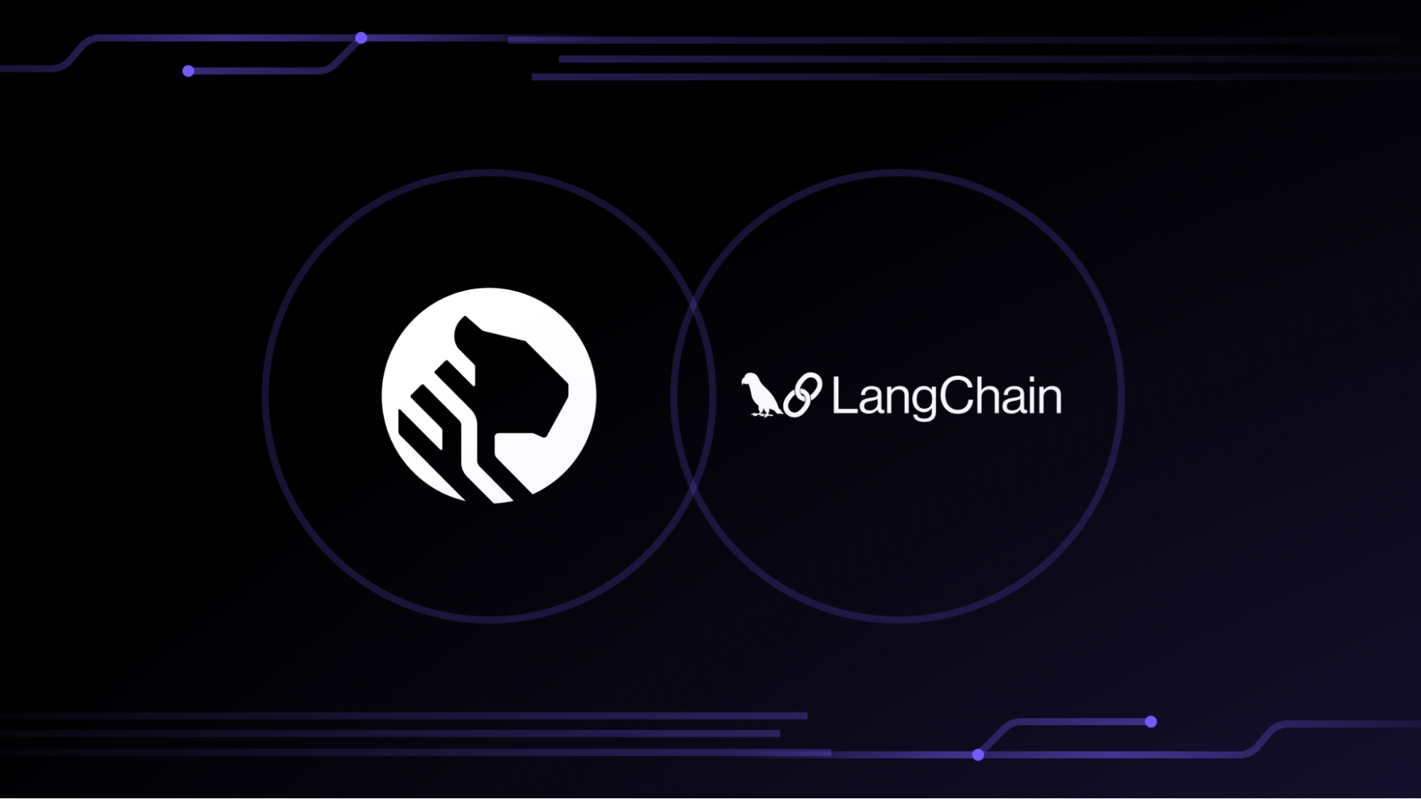

Preprocessing

vector, time, metadata
Parser
Pure Python
Operations Key

string, datetime
Vectorize Agent
LangChain (LLAMA 3B backend)
User Query

Retrieval
Retrieve top 10 messages
(filter & cos-sim)
[Retrieved Messages + Metadata]
Query Vector, Metadata Filters
[Retrieved messages ± context]
SelfQuery Agent

Relevance Critic
TimescleDB
Add Context Agent (±5 messages)
[Retrieved messages ± context] (filtered)

Summary
Summary Agent
Add Context Agent (±10 messages)

The first improvement we noted was that the LLM Relevance Critic did its job very well. From our informal testing, we saw that irrelevant threads were not passed to the summary agent (when we later conducted formal evaluation, we did not see any blatantly irrelevant information in Model 1’s outputs).

The next improvement we saw was the result of SelfQuery. SelfQuery is an interface that LangChain exposes for database retrievers which uses an LLM to rewrite queries so that they incorporate filters on metadata. TimescaleDB provides a SelfQuery implementation that allows us to filter by comparators on metadata fields. This means that we can ask questions like “Which films did my friends watch in February this year?” and SelfQuery will write boolean filters and(and(gte("DATETIME", "02-01-2025"), lt("DATETIME", "03-01-2025")), eq("CHATROOM", "Chat_Friends")) based on the metadata fields DATETIME, CHATROOM, their datatypes, and/or their possible values. There were some drawbacks, i.e., SelfQuery does not support substring as a comparator, so asking about someone by just their first name would mean that no matches were found in the TimescaleDB. The results we got were still qualitatively poor a lot of the time, so we devised a new strategy.

(For your reference, we presented Model 1 in Presentation #3 on February 25th)

Model 2 (Semantic Chunking)
Model 2 relies on the concept of semantic chunking. One of the failure modes of Model 1 is that the embedding vectors that are saved to the TimescaleDB are always based on eleven-message context windows. There is no reason, however, why eleven is a good hyperparameter or that this should be any fixed quantity for all our systems’ users. We used Semantic Chunking as described in “ChunkRAG: Novel LLM-Chunk Filtering Method for RAG Systems” (Singh et al., 2024). To use Semantic Chunking, we first get embedding vectors for all the messages in a chatroom and find the distribution of cosine similarities for all messages (this is the “semantic part”). To chunk, we linearly iterate over the messages, adding them into a chunk until the cosine similarity of two messages is lower than the 90th percentile of the cosine similarity distributions. Across Krishna’s WhatsApp chat logs, this results in about 13 messages per chunk.

We updated Model 2’s stack to the following:

Preprocessing
Parser
Pure Python
Operations Key

string, datetime
Semantic Chunking Agent
LangChain (Google Gemini backend)
User Query

Retrieval
Retrieve top 10 messages
(filter & cos-sim)
[Retrieved Messages + Metadata]
Query Vector, Metadata Filters
[Retrieved messages ± context]
SelfQuery Agent

Relevance Critic

vector, time, metadata
TimescleDB
[Retrieved messages ± context] (filtered)

Summary
Summary Agent
Add Context Agent (get all messages in a chunk ± a few messages)

We were able to reuse many of the components from Model 1 when programming Model 2. There were some minor engineering changes we made to the base library to make our app more effective. We first changed SelfQuery’s retrieval function to return at least ten conversation snippets every time. This change was necessary because including words like “a” in a question sometimes made SelfQuery set the retrieval limit to one. We also removed the AUTHOR field from the available SelfQuery metadata fields for two reasons: it was searching for string equality on names which did not work with the use case of the app, and semantic chunking meant that multiple authors’ messages were present in most chunks. Because we still wanted to search by author, we explicitly prompt the agent that summarizes chunked messages in the preprocessing stage to include information about author names.

Since our vector database now included summaries of message chunks, we needed to rewrite our context retrieval script to get the full context. We saved the ID of the first message and the number of messages for each chunk in the TimescaleDB’s metadata fields. To adjust for minor errors in semantic chunking break points, we add additional messages to both ends of the chunk. (The number of additional messages is inverse-exponentially proportional to the chunk’s size, but always at least one).

After upgrading the LangChain agents to use Google Gemini as the LLM backend, we were able to run more complicated tasks. These are post-processing steps that improve the usability and credibility of our app. The first feature we added was a hallucination agent. This checks that the final summary is consistent with the information in the filtered documents. We also used an LLM to highlight locations in the document that correspond to text in the summary. We display this critique to the user, alongside the highlighted retrieved documents in a details page attached to all of our app’s outputs.

A summary of the app integration at this stage is shown in the diagram below:

Preprocessing
Parser
Pure Python
Operations Key

string, datetime
Semantic Chunking Agent
LangChain (Google Gemini backend)
User Query
Retrieval
Retrieve top 10 messages
(filter & cos-sim)
Query Vector, Metadata Filters
[Retrieved messages ± context]
SelfQuery Agent

Relevance Critic

vector, time, metadata
TimescleDB
[Retrieved messages ± context] (filtered)
Summary Agent
Add Context Agent (get all messages in a chunk ± a few messages)

Summary
[Retrieved Messages + Metadata]
Front End
User Query

display_w_supporting_snippets()

HTTP
POST
HTTP
POST
Flask Server

(For your reference, we presented Model 2 at this stage during Presentation #4 on March 13th)

We also incorporated the username : real name map from the app’s friend tab. We debated whether this information should be incorporated during the preprocessing or answer generation stage. We decided that because Semantic Chunking deprecated the AUTHOR field from the TimescaleDB, we would get most functionality out of the friends list during retrieval time. (We faced a tradeoff between availability and precision. Every time the user adds new friends, their app would be unavailable for 20+ minutes as the backend updates. A drawback of this approach is that the embedding vectors of the requested name and username would differ.)

Another bonus feature we added for the app was the “recent” keyword for questions. If a user’s question includes the substring “recent,” our app will use a filter on chunk’s DATETIME field so that only message chunks from the last day are retrieved. If an LLM critic is unhappy with the quality of the model’s response, the minimum date will be pushed back to three days from the present. The critic evaluates the new response, then repeats the process with a one week, two week, one month, three month, six month, one year, two year, five year ago start date filter until it gets a satisfactory response.

A summary of the full app integration is shown in the diagram below:

Preprocessing
Parser
Pure Python
Operations Key

string, datetime
HTTP POST
Semantic Chunking Agent
LangChain (Google Gemini backend)
User Query, Date Filters
Retrieval
Retrieve top 10 messages
(filter & cos-sim)
Query Vector, Metadata Filters
[Retrieved messages ± context]
SelfQuery Agent

Relevance Critic

vector, time, metadata
TimescleDB
[Retrieved messages ± context] (filtered)
Summary Agent
Add Context Agent (get all messages in a chunk ± a few messages)
Quality Checks
Hallucination Critic
Highlighter Agent
Yes/No
[Highlighted messages]

Summary
[Retrieved Messages + Metadata]
[Retrieved Messages + Metadata]
Replace Nickname Agent
Front End
User Query

contains(‘recent’)
Loop through values of start_date

start_date := NaT

N
Y
display_w_higlights()
N
Y
critic_satisfied()

HTTP POST
Flask Server
Friends Info

Product Evaluation

Engineering the Evaluation Metrics
To evaluate our model, we used a LLM as a grader with a structured JSON output of the format:

class Evaluation(BaseModel):
score: int = Field(..., description="The score given to the model's response")
reasoning: str = Field(..., description="The reasoning for the score")
model_answer: str = Field(..., description="The answer provided by the model")

We first began by using a 1-10 scale, giving the LLM Grader the prompt below that leverages chain of thought reasoning and string format blocks {var_name} where we will inject questions, answers, or supporting messages at evaluation time.

The first simple, naive prompt we tried doesn't discuss any rubric items and gives a rating on a 1-10 scale. This ultimately didn't work too well as the scores were not extremely interpretable and it was hard to distinguish between the difference in say a 3 and a 4 rating. We also noted that most scores were at the extremes -- either 1s and 2s, or 9s and 10s -- as most often it came down to if during retrieval the model found the correct set of documents or not.

"""You are an agent designed to evaluate whether an answer to a prompt or question is correct or not.

You will be given a ground-truth answer with a set of corresponding messages, and the answer provided by the model. Give a score 1-10 on how well the model answered the question.

Here is the question:

{question}

Here is the response provided by the model:

{model_response}

Here is the ground-truth answer:

{ground_truth}

Here are the ground_truth supporting messages:

{ground_truth_supporting_messages}

Provide reasoning for your score.
"""

Next, we narrowed the scoring range to be on a 1-5 scale and provided some simple examples and short rubric items to give. This worked a little better, but scores in the 2-4 range were still a little up in the air as it was difficult to differentiate between them.

"""You are an agent designed to evaluate whether an answer to a prompt or question is correct or not.

You will be given a ground-truth answer with a set of corresponding messages, and the answer provided by the model. Give a score 1-5 on how well the model answered the question.

1: The answer is completely incorrect or the model could not find any answer. For example, the answer is "I don't know."

or if the correct answer is "The sky is blue," the model's answer is "The sky is green."

2: The answer is vague and doesn't include any specific information. For example, the correct answer is "The sky is blue,"

but the model's answer is "The sky is a color."

3: The answer includes part of the correct information or references the correct information but is not complete.

For example, the correct answer is "The sky is blue and the grass is green," but the model's answer is "The sky is blue."

4: The answer is mostly correct but has some minor errors or omissions. It doesn't include anything wrong,

but it doesn't include everything right. For example, the correct answer is "The sky is light blue,"

but the model's answer is "The sky is blue."

5: The answer is completely correct and includes all relevant information. No errors or omissions.

For example, the correct answer is "The sky is blue," and the model's answer is "The sky is blue."

Here is the question:

{question}

Here is the response provided by the model:

{model_response}

Here is the ground-truth answer:

{ground_truth}

Here are some (optional) ground truth supporting messages:

{ground_truth_supporting_messages}

Provide reasoning for your score.
"""

We then elected to move down to a 1-3 scale, which, while not as granular, can more easily be classified by a person. This separates evaluations into three distinct classes -- either there is no answer or the answer is wrong, the answer is partially correct but may have errors or is not complete, or the answer is entirely correct. We also used examples that more aligned with the types of questions, answers, and documents it would be receiving.

"""You are an agent designed to evaluate whether an answer to a prompt or question is correct or not.

You will be given a ground-truth answer with a set of corresponding messages, and the answer provided by the model. Give a score 1-3 on how well the model answered the question.

1: The answer is incorrect or the model could not find any answer.

2: The answer is partially correct but has some errors or omissions.

3: The answer is completely correct and includes all relevant information. No errors or omissions.

Note: If the model response gives more information than required, that is acceptable as long as the additional information is not incorrect.

Examples:

question: "When is Bentley's Belated Birthday party?"

model_response: "On the 23rd, at 8pm. There will be cake and ice cream."

ground_truth: "On the 23rd"

ground_truth_supporting_messages: ["Bentley's Belated Birthday party is on the 23rd"]

score: 3

reasoning: The model response is correct and includes all relevant information. The additional information about cake and ice cream is not incorrect.

question: "What was Kasten’s game plan for 12/19/2024?"

model_response: "nap until 8pm. do some work. go to the roof and watch the sunset."

ground_truth: "nap until 8pm"

ground_truth_supporting_messages: ["Kasten's game plan for 12/19/2024 was to nap until 8pm"]

score: 3

reasoning: The model response is correct and includes all relevant information. The additional information about doing some work and watching the sunset is not incorrect.

question: "What is Richard's favorite color?"

model_response: "Richard likes shades of bluish-green."

ground_truth: "red"

ground_truth_supporting_messages: ["Richard's favorite color is red."]

score: 1

reasoning: The model response is incorrect. Richard's favorite color is red, not shades of bluish-green.

Here is the question:

{question}

Here is the response provided by the model:

{model_response}

Here is the ground-truth answer:

{ground_truth}

Here are the ground_truth supporting messages:

{ground_truth_supporting_messages}

Provide reasoning for your score.
"""

We then output a json file with the model’s answer, ground truth answer, the evaluator’s score, and the evaluator’s reasoning.

Evaluation Results
We finally found the following results after testing on 312 manually and LLM generated questions based on Krishna’s WhatsApp chats. To make the comparisons fair, we use Google Gemini as the embedding vectorizer and agent base model, and ChatGPT as the critic for all of these tests.
 | Model 1 | Model 1 + SelfQuery | Model 2 | Model 2 + SelfQuery
Average Score  (2 SEM Confidence Interval) | [1.870, 2.079] | [1.709, 1.921] | [2.135, 2.344] | [2.160, 2.369]
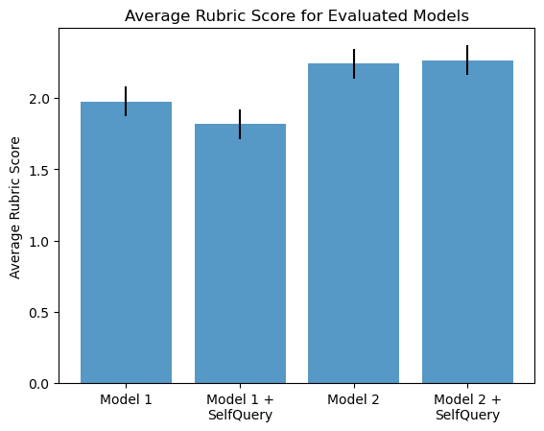
The switch to semantic chunking caused a significant improvement in the scoring. This is consistent with our qualitative observations.
SelfQuery did not significantly improve the performance of either model. However, we had trouble ensuring that SelfQuery consistently returned properly formatted datetimes, which resulted in thrown exceptions. We removed the datetime field from SelfQuery when running the evaluation metrics which neutered its effectiveness. With more time, understanding and robustly integrating SelfQuery would be one of our top priorities.

Bibliography
@misc{singh2024chunkragnovelllmchunkfiltering,
title={ChunkRAG: Novel LLM-Chunk Filtering Method for RAG Systems},
author={Ishneet Sukhvinder Singh and Ritvik Aggarwal and Ibrahim Allahverdiyev and Muhammad Taha and Aslihan Akalin and Kevin Zhu and Sean O'Brien},
year={2024},
eprint={2410.19572},
archivePrefix={arXiv},
primaryClass={cs.CL},
url={https://arxiv.org/abs/2410.19572},
}

Contributions
Krishna:
I initially worked on creating models for our dataframes and databases. Then I worked on integrating our messages with Kasten’s LangChain code to make Model 0 work. I modified code from TimescaleDB x Langchain tutorial to make Model 1, as well as wrote the Python subroutines. I also incorporated a semantic chunking tutorial into Model 2, and wrote Python scripts to get additional context based on the chunk metadata. I incorporated Richard’s friends list as well as a Reliable RAG tutorial to improve the user experience.
In all, I think I spent 45 hours on the project, 30+ of which were in the last couple of weeks when I got the hang of LangChain and how to use the debugger to find which internal functions to overwrite.
Kasten:
Worked on: RAG engineering and design, question generation, and evaluation. Also worked on modularizing the backend code for scaling and handling different chat message histories (like both WhatsApp and Discord), although I didn't get this fully integrated with all of the features Krishna added.
Week 4:
- I began by working from a basic, example RAG setup my friend made using Chroma DB with Gemini, editing it to use putting 1000 discord messages into a vector db (downloaded chat history using a chrome extension and then processed it with pandas)
- Hours: 7
Week 5:
- I started exploring using different models (deepseek, lamma, gemini) and edited the code to use LangChain. At this point, Krishna and I were also testing different ways to include message context (either including the context in the embeddings, or adding it after). I also began on a LangGraph course to understand some techniques and setup an OpenAI account to use for the project.
- Hours: 7
Week 6:
- I started trying to build my own model . I also set out to
- Hours: 6
Week 7:
- I worked on generating questions for evaluation. Richard gave some manually created ones, and then I created a question generator using
- Hours: 6
Week 8:
- Set up selfquery and multiquery and ran them with evaluation. Also began modularizing the code
- Hours: 7
- Notes: At this point I still was having trouble setting up timescale on my laptop, so for selfquery I tried to convert datetimes to integers for queries. While this worked sometimes, it ultimately was not reliable enough.
Week 9:
- I configured my set up for evaluation to use Krishna's API endpoint and compared this to using my local multiquery setup.
- Hours: 7
Week 10:
- Wrap up and writing
- Hours: 2
Final notes:
Note: hours are not exact as I don't remember too well. I put a number of hours into testing out various methods that didn't make it into the final project (such as using tool calls to give an agent the ability to query for more information like a user profile).
Richard:
I was responsible for implementing our mobile app’s frontend and integrating it with the backend server hosting the LLMs. To that end, I designed the user interfaces, in-app interactions, and the process for displaying output returned by the LLM. With reference to the more technical aspects of the frontend work, I implemented the app’s state management and the network requests required to send user queries to and receive responses from the backend server. Other tasks that I accomplished for the purpose of designing the user experience include form validation, settings to manage chat and search history, and the ability to add profiles for friends the user might wish to associate with. In terms of hours contributed, my ballpark estimate is that I contributed around 60-70 hours to the project, which includes time spent in group meetings.

